Civil war in Somalia

UNSC Resolution: | 751
Date of adoption: | 24-Apr-1992
Operative paragraph: | 15
Demand number: | 751,1511

Sarah-Myriam Martin-Brûlé

Wording of demand

cooperate fully with the Secretary-General in the implementation of the present resolution

List of addressees of the demand

Government of Somalia, United Somali Congress Faction

Short-term compliance

Description of the addressee(s)’ conduct

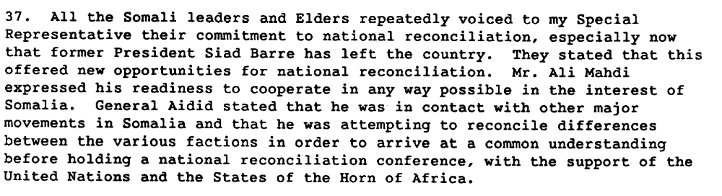

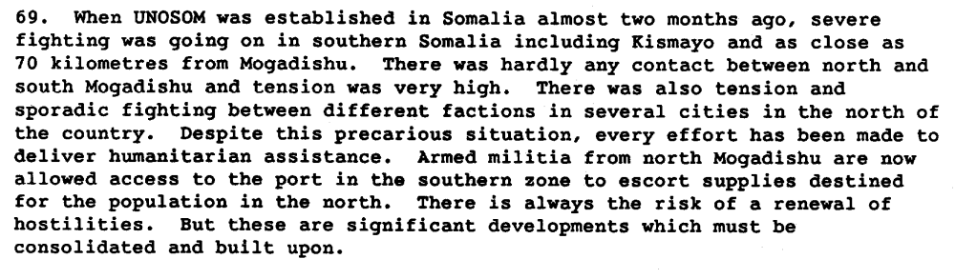

Report of the Secretary General on the Situation in Somalia, S 24343, 22 July 1992.

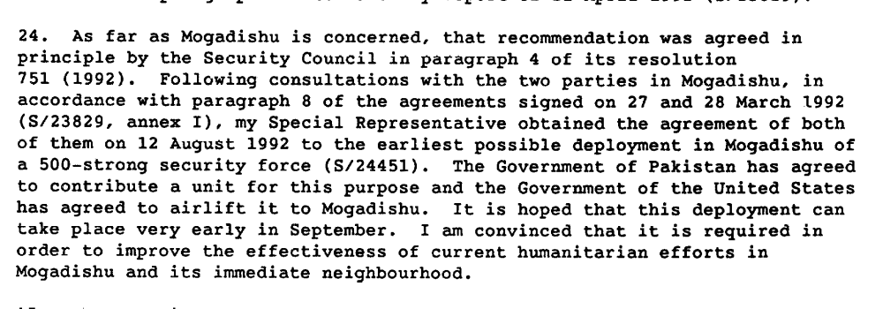

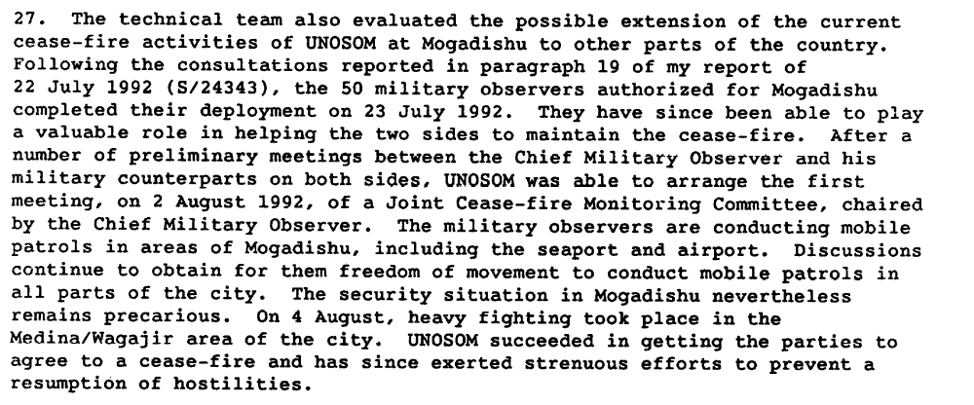

Report of the Secretary General on the Situation in Somalia, S/24480, 24 August 1992.

Assessment

Short-term compliance
X No or marginal compliance (1) | Medium low compliance (2) | Medium high compliance (3) | Full or almost full compliance (4)

Considerations underlying the assessment
Although the demand addressees seem to initially agree on the resolution, they did not cooperate fully with the Secretary-General in the implementation of the present resolution.

Medium-term compliance

Description of the addressee(s)’ conduct

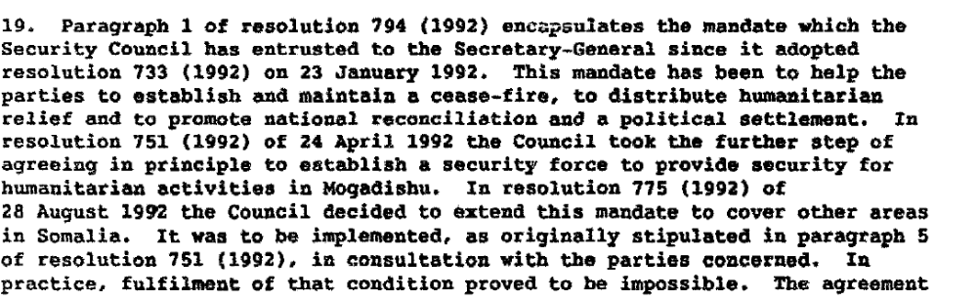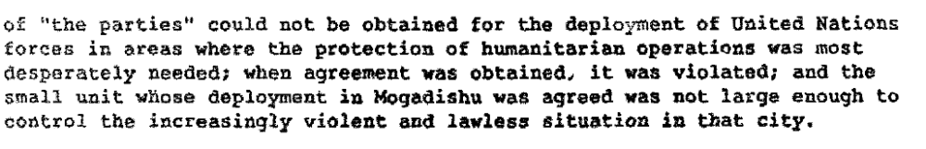

Report of the Secretary General on the Situation in Somalia, 19 December 1992 S/24992/.

Assessment

Medium-term compliance
X No or marginal compliance (1) | Medium low compliance (2) | Medium high compliance (3) | Full or almost full compliance (4)

Considerations underlying the assessment

Within the two years following the adoption of the resolution, the demand addressees did not cooperate fully with the Secretary-General in the implementation of the present resolution.

Depth of demand

Assessment

Level of depth of demand
Low depth of demand (1) | X Medium depth of demand (2) | High depth of demand (3)

Considerations underlying the assessment
Given the insecurity of the national setting, and in the absence of guarantees that the other demand addresses would also comply, compliance with this demand made it significantly more difficult for the demand addresses to attain victory in the civil war.

Level of confidence about coding decisions

Level of confidence about coding decision
Extremely high | X High | Moderate

Comments to IPI (if any)

